Module 6 Assignment
Krishna M
Mepco Schlenk Engineering College, Sivakasi

- Capture and analyze ARP packets using Wireshark. Inspect the ARP request and reply frames when your device attempts to find the router's MAC address.

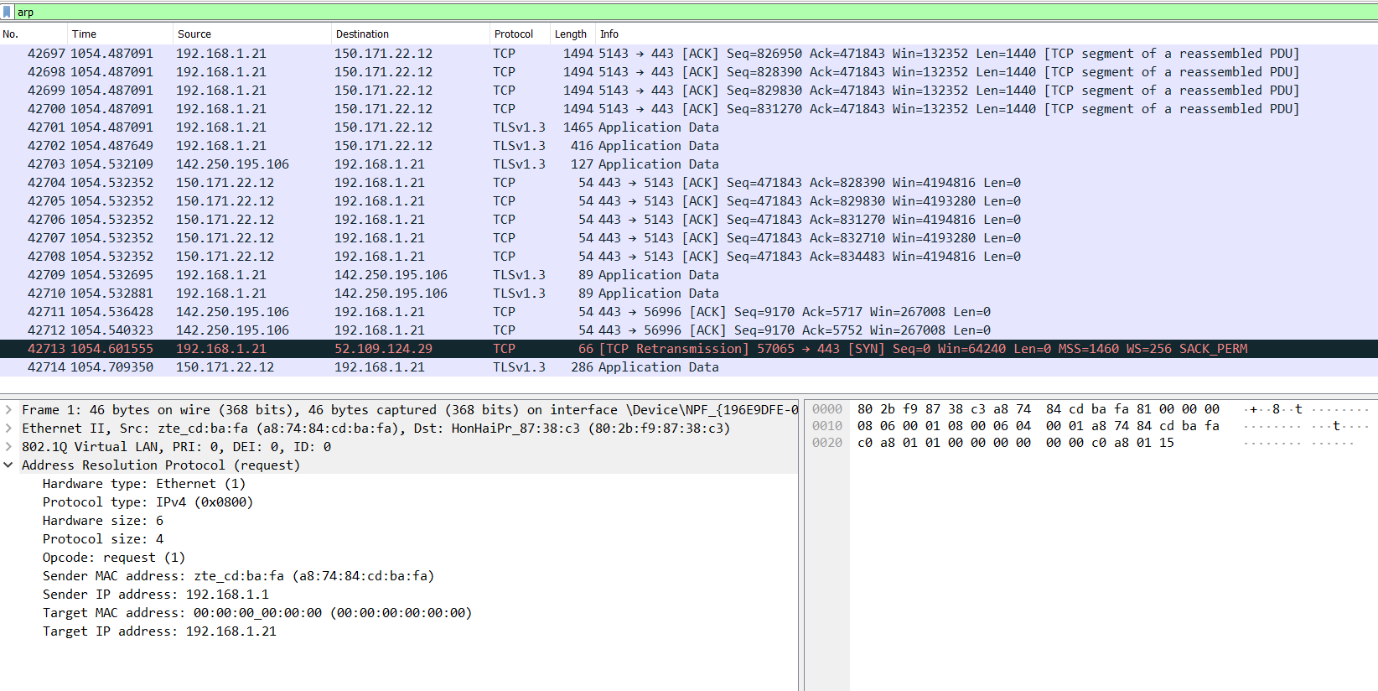

- Manually configure static routes on a router to direct packets to different subnets. Use the ip route command and verify connectivity using ping and traceroute.

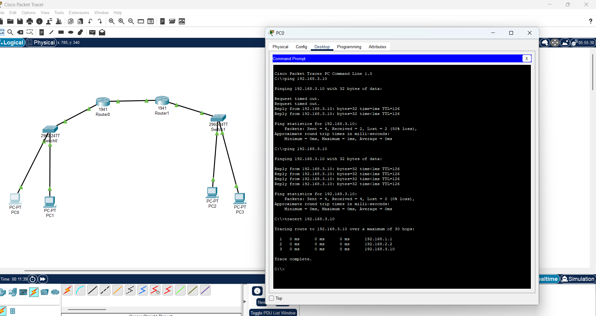

- Given a network address of 10.0.0.0/24, divide it into 4 equal subnets.Calculate the new subnet mask.Determine the valid host range for each subnet. Assign IP addresses to devices in Packet Tracer and verify connectivity.

Given Network: 10.0.0.0/24 (Subnet Mask: 255.255.255.0)
We need 4 subnets, so we borrow 2 bits from the host portion.
New Subnet Mask: /26 (255.255.255.192)
Each subnet now has:
64 IPs (2^6)
62 usable host IPs (excluding network and broadcast IPs)

Subnet Network Address First Usable IP Last Usable IP Broadcast Address
Subnet 1 10.0.0.0/26 10.0.0.1 10.0.0.62 10.0.0.63
Subnet 2 10.0.0.64/26 10.0.0.65 10.0.0.126 10.0.0.127
Subnet 3 10.0.0.128/26 10.0.0.129 10.0.0.190 10.0.0.191
Subnet 4 10.0.0.192/26 10.0.0.193 10.0.0.254 10.0.0.255

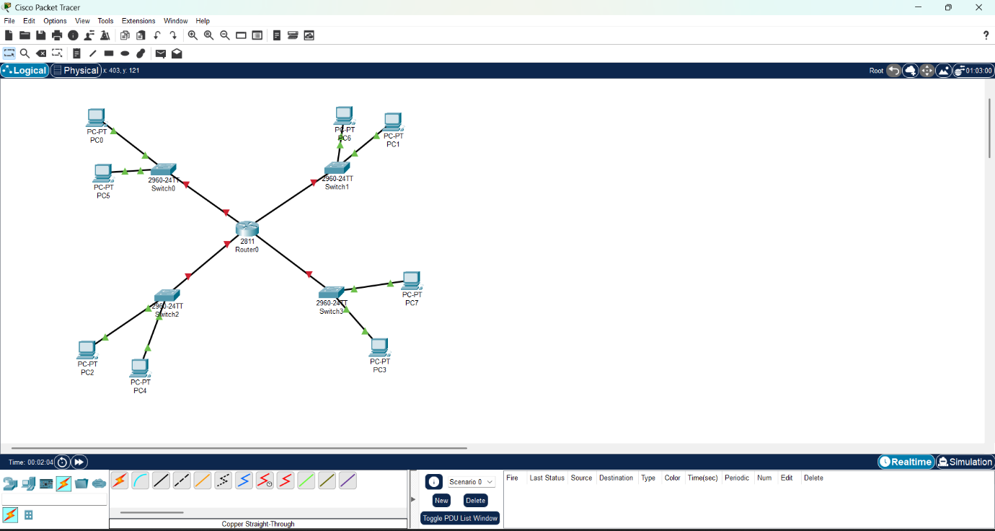

- You are given three IP addresses: 192.168.10.5, 172.20.15.1, and 8.8.8.8. Identify the class of each IP address. Determine if it is private or public. Explain how NAT would handle a private IP when accessing the internet.

IP Address Class Private/Public IP Range for Class
192.168.10.5 Class C Private 192.0.0.0 – 223.255.255.255
172.20.15.1 Class B Private 128.0.0.0 – 191.255.255.255
8.8.8.8 Class A Public 1.0.0.0 – 126.255.255.255

Private IP addresses (192.168.10.5 and 172.20.15.1) cannot be routed on the public internet.
Network Address Translation (NAT) allows devices with private IPs to communicate over the internet by converting private IPs into a single public IP address assigned by an ISP.
How NAT Works:
A device with a private IP e.g., 192.168.10.5 sends a request to access a public server e.g., 8.8.8.8.
The router performing NAT replaces the private source IP like 192.168.10.5 with a public IP e.g., 203.0.113.10.
The response from the public server is received by the router.
The router uses a NAT translation table to forward the response back to the correct internal device (192.168.10.5).

- In Cisco Packet Tracer, configure NAT on a router to allow internal devices (192.168.1.x) to access the internet.Test connectivity by pinging an external public IP. Capture the traffic in Wireshark and analyze the source IP before and after NAT translation.

